|  |  |  |
| --- | --- | --- |
| **Qatar University**  **College of Engineering**  **Dept. of Computer Science & Eng.** | **quLogo94x89NT** | **Software Engineering**  **CMPS 310** |

**Lab 8: Design Sequence Diagram**

**Case Study: All Phones Shop (APS)**

**Student Name: Talha Abdullah Student ID: 201903446_________**

**Enter your work here**

|  |  |  |
| --- | --- | --- |
| **Use case Id:** UC**001** | **Create registration** | |
| **Brief Description** | The client wants to create a registration. The APS system creates a registration for a client and inform the PoB about the new client registration | |
| **Primary actors** | Client, PoB. | |
| **Trigger(s)** | The client selects the registration function. | |
| **Preconditions:**   1. The client must not exist. | | |
| **Post-conditions:**  1. A client registration is created. | | |
| **Main Success Scenario:** A client registration has been created. | | |
| **Actor Action** | | **System Response** |
| 1. The client provides details | | 2. Check if the client exits |
|  | | 3. Create a registration with the client details if the registration does not exist. (See 3.a. for alternative flow) |
|  | | 4. Assign a unique number to the registration |
|  | | 5. Advise PoB about the new client . |
|  | | 6. Inform the client with the registration number. |
| **Alternative flows:**  3.a. If the client already exists, inform the client that a new registration cannot be created. | | |

**DSD for “Create registration”**

|  |  |  |
| --- | --- | --- |
| **Use case Id:** UC01 | Sell Item | |
| **Brief Description** | This use case beings once a client wants to sell an item. The system receives the item information from the client and records the item for sale. | |
| **Primary actors** | Client | |
| **Trigger(s)** | The client wants to sell an item | |
| **Preconditions:**   1. The client has an existing account 2. The client has either smartphone, normal mobile phone, or land phone to sell. | | |
| **Post-conditions:**   1. Item is listed and will be available for sale | | |
| **Main Success Scenario:** The item has been successfully recorded | | |
| **Actor Action** | | **System Response** |
| 1. client selects the category of the item | |  |
| 1. The client provides the item details | | 1. Records the item details |
|  | | 1. Ask to select the sale option (auction or fixed price) |
| 1. The client selects the sale option | | 1. Asks the client to submit the starting price and the end of the auction time (see alternative flow 6.a) |
| 1. The client submits the information requested | | 1. Assigns an ID to the item |
|  | | 1. Attach the item with the client registration |
|  | | 1. Inform the client about the information submitted for sale |
|  | | 1. <include: “Create a catalog entry”> |
| **Alternative flows:**  6.a. If the client selects the selling by fixed a price, the system asks the client to submit a fixed price and continue from step number 7 | | |

**Task 4.1: Paste your DSD for “Sell item” <<Here>>:**

1. **First Draft <<Paste your diagram here>>**

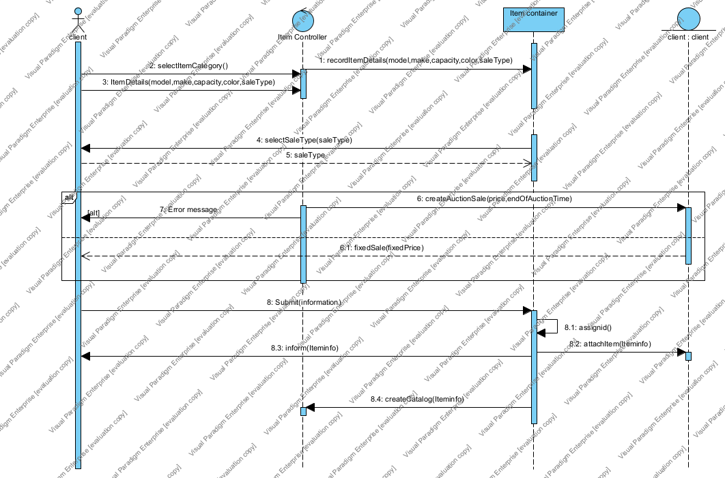

1. **Second Draft <<Paste your diagram here>>**

|  |  |  |
| --- | --- | --- |
| **Use case Id:** UC02 | Buy item on auction | |
| **Brief Description** | The client can bid for an item on sale. The system records the information, finds the highest bidder at the end of the sale and notify the winner. | |
| **Primary actors** | Client | |
| **Trigger(s)** | The client wants to buy an item by auction | |
| **Preconditions:**   1. The client must exist 2. The item is available 3. The auction time must be valid | | |
| **Post-conditions:**   1. A winner has been declared 2. The item status is changed to “sold” | | |
| **Main Success Scenario:** The system has successfully declared a winner and the status of the item is changed | | |
| **Actor Action** | | **System Response** |
| 1. The client selects an item | | 2. Asks the client to provide a bid |
| 1. The client provides a bidding price | |  |
|  | | 1. Validates the bidding price submitted (see 3. a) |
|  | | 1. Records the bid with the client registration |
|  | | 1. Find the highest bid at the end of the auction time |
|  | | 1. Notify the client with the highest bid |
|  | | 1. Change the status of the item to “sold” |
|  | | 1. <include: “Remove from catalog”> |
|  | | 1. <include: “Create invoice”> |
| **Alternative flows:**  4.a. If the bid is less than accepted bid, bid is rejected, and asks the client to bid again with a higher price | | |

**Task 4.2: Paste your DSD for “Buy on auction” <<Here>>:**

1. **First Draft <<Paste your diagram here>>**

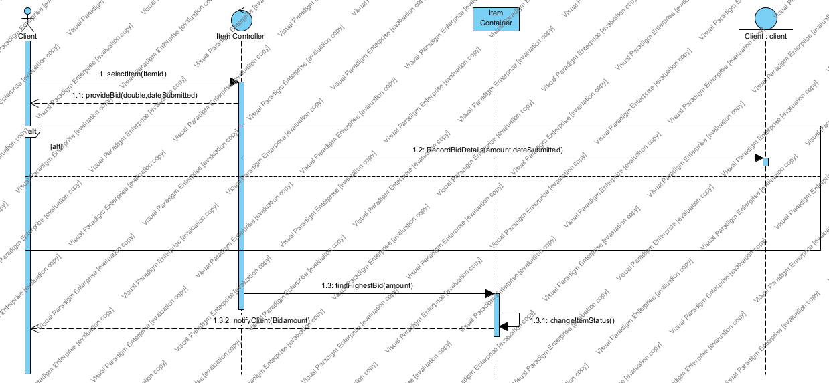

1. **Second Draft <<Paste your diagram here>>**

**Task 4.3: Paste your updated class diagram <<Here>>:**

